Ethno-Federalism in Ethiopia – 30 Year Amhara Genocide

Mortaza Sahibzada [Draft, 14 Oct 2022]
This paper outlines two phases of the genocide against the Amhara people that took place 1991-2018 (under the Tigray-dominated regime) and continues 2018-present (under the current Oromo-centric regime).* Some details are provided on the Amhara resistance (‘Fano’) who act against their genocide and for the integrity of the entire Ethiopian territory.
__________________________

Introduction
The Amhara genocide is an ongoing systematic massacre of ethnic Amhara (and/or Agew) people in Ethiopia since 1991. Large-scale killings and grave human rights violations anticipated and followed the establishment of an ethno-federalist state constitution in 1994. In most of the cases, the mass murders remain undocumented with perpetrators from various ethno-militant groups, especially the Tigray People's Liberation Front (TPLF) or Tigray Defense Forces (TDF), as well as the Oromo Liberation Front (OLF) or Oromo Liberation Army (OLA) including or alternatively referred to as the Shene, Oneg and Gumuz militias, in addition to the violence of state security/military forces (it is not suggested that these groups necessarily act in concert; they have sometimes been in conflict with one another, but find common cause in the genocide here outlined). Mass graves of Amhara victims have been discovered in various locations. Attempts by individuals or rights groups to investigate and to expose the atrocities result in systematic persecution. Two consecutive national censuses as well as a report by the state have revealed that over 2 million Amhara cannot be traced. The figure reflects the decades-long massacres and enforced disappearances of the Amhara people (millions more have been displaced), which remain ongoing. The Amhara genocide has taken place in two phases, 1991-2018 and 2018-present, under the former TPLF-dominated regime and the current, more Oromo-centric, Abiy Ahmed administration. These two regimes have engaged in the expansion of the Tigray and Oromo regions, attempting to extend ethnographic hegemonies over largely Amhara-populated provinces through ethnic cleansing. Protest and resistance to these occupations has been carried out by various groups (supported by nationalist and diaspora movements), including the ‘Fano’, formed of farmers, traders, doctors, engineers etc, that traces its mandate to the resistance against Mussolini’s occupation of Ethiopia (as Amnesty International has documented, Fano or associated ‘vigilante’ youth groups are not without blame for atrocities).
Beyond the genocide of its people, this paper contends that Amhara culture (which has historically proven resistant to imperialism) has since the 70s been under sustained attack by genocidal forces from all quarters – communist, western, Arab, African – in order to break its unique capacity for intercommunal interactions and bonding.
__________________________

Prelude (1974-1991) and Amhara Genocide, Phase 1 (1991-2018)
The TPLF and OLF, formed in the mid-70s at the same time as the student movement and widespread protests against the government and monarchy, were products of communal splintering, armed and youthful, influenced by the militant, anti-feudal Marxist/Leninist ideology that accompanied internecine conflicts within numerous countries. After the period of civil unrest that began in February 1974, a council of soldiers, known as the Derg (‘committee’) seized power from the ageing emperor Haile Selassie in September 1974 (they executed numerous members of the former administration including two former prime ministers, royal crown councillors and officials, ministers, and generals; Haile Selassie died in August 1975, allegedly strangled or smothered in his palace). The Soviet-backed Derg established a military-socialist state (latterly the People's Democratic Republic of Ethiopia, including Ethiopia and present-day Eritrea, that existed from 1987 to 1991 with the Derg rebranded as the Workers’ Party of Ethiopia). This did not put a stop to ethno-militancy. As well as the TPLF and OLF, Eritrean separatists organised as the Eritrean Liberation Front (ELF) long sought independence. Along with the emergence of anti-communist forces and rebels fighting for civilian rule, civil war ensued. The civil war lasted for the entire 17-year communist period (1974-1991), coming to an end along with the collapse of the Soviet Union, and resulting in the secession of Eritrea, and victory for the TPLF (and other Tigray-affiliated groups) in now landlocked Ethiopia.
The UK and USA may have begun to support the TPLF during the 80s in order to assist in the overthrow of the communist regime (it is difficult to put a precise date on it, but it may have been following the momentous Live Aid famine relief concerts in London and Philadelphia in July 1985 that operatives gained a foothold amongst aid personnel who had to deal with militias to facilitate distribution; Anglo-American support was certainly forthcoming as the TPLF was forming the new ethno-structured regime with regional demarcations as such in the early 90s). This was despite a CIA report and other papers describing the aforementioned ‘liberation’ groups as insurgents committed to racial self-determination/independence from central government, of which the TPLF seeking autonomy, secession, or hegemony, its manifesto and ethos blaming the Amhara people for socioeconomic and historicopolitical national problems, and considering the Tigray as sole defenders of Ethiopian culture and Christian orthodoxy. In fact, Amhara people were traditionally committed to a unitary Ethiopia, with a long history of celebrating the multi-ethnic, multi-religious nation that was always resistant to colonisation, for example overcoming Italian occupation as mentioned, and why imperial/regional powers turned to other ethnic groups to weaken Ethiopian independence and national integrity. However, some of the socialist/liberation groups based in Amhara-populated provinces, in particular the Ethiopian People’s Democratic Movement (see below), were finally subordinated to the ethno-federalist agenda of the TPLF and, later, Amhara nationalist groups also sprung up as the intercommunal violence escalated (the latter is reflected in some of today’s protest groups who use the slogan ‘One Amhara’ rather than ‘One Ethiopia’). The overriding conflict between Amhara and Tigray peoples occurs despite their shared religious heritage.
Whereas the killing of Amhara elites and diplomats began in 1974 under the Derg junta, the mass violence against Amhara, including intellectuals and civic leaders, started in 1991 as the TPLF gained control. The scale of attacks intensified even as a transitional government was formed in that year, largely controlled by the Ethiopian People’s Revolutionary Democratic Front (EPRDF), a coalition of parties that ushered in the realignment of regional boundaries on the basis of ethnolinguistic identity and would dominate Ethiopian politics for 27 years (1991-2018). The EPRDF comprised the TPLF as the dominant partner along with three other parties, as follows. The Ethiopian People’s Democratic Movement was formed as a splinter of the Ethiopian People’s Revolutionary Party that was prominent in the 1974 student movement, as already noted; this was originally a pan-Ethiopian movement, but as some its members came to be allied with the TPLF it became more identified with ethnicity and region; it changed its name to the Amhara National Democratic Movement in 1994 when the new constitution based on ethno-federalism was instituted and has been accused of disciplining the Amhara people instead of representing them (much like the Palestinian Authority); toward the end of the EPRDF period it was renamed to the Amhara Democratic Party. Next, the Oromo People’s Democratic Organization was formed ad hoc from Oromo-speaking war prisoners captured by the TPLF; it was not popular, given the ongoing conflict between the TPLF and the OLF, and prominent members of the Oromo community rejecting the TPLF call to join an ethnicity-oriented coalition; toward the end of the EPRDF period it was renamed the Oromo Democratic Party. Finally, and the Southern Ethiopian People’s Democratic Movement was formed out of the Southern Ethiopia People’s Democratic Front.
As indicated, the TPLF vision for regional demarcations took shape in the early 90s. It would be enshrined in Article 39 of the 1994 constitution (Nations, Nationalism and Self-Determination of Peoples) granting rights to any ethnic group to regional autonomy and if necessary, secession. The impetus being to extend the boundaries of its ethnic dominion, a greater Tigray region was envisaged that involved the annexation of lands from neighbouring provinces, resulting in sporadic massacres, disappearances, and ethnic cleansing of the Amhara population. Immediately after the TPLF gained control through the transitional government of 1991, the Raya-Alamata and Welkait lands were annexed into the Tigray region; then Gondar and Bethe-Amhara Wollo were occupied (these lands have been ruled as southern and western parts of Tigray for three decades, but since late 2020 Amhara have been fighting to regain access to these historical lands). Likewise Metekel, previously part of the historic Gojjur province, a strategic area with access to the Blue Nile river, was apportioned to the Benishangul-Gumuz region to moderate the geographical distribution of the Amhara population and the sphere of their influence (intercommunal conflict in Metekel has raged in particular since 2019 with the involvement of Sudan and Egypt, who oppose the Grand Ethiopian Renaissance Dam hydroelectric project in Metekel, claiming exclusive rights to the Nile water that originates in Ethiopia, based on illegitimate colonial-era treaties that sought to diminish the influence of an impenetrable Ethiopia). With the ongoing violence against the Amhara and Agew who live in areas annexed or occupied during the TPLF-led era (Table 1 lists further such examples), grave concerns remain about their lack of political representation and protection.
__________________________

Amhara Genocide, Phase 2 of 2 (2018-current)
The second phase of the Amhara genocide began in 2018 as an Oromo-leaning administration came to power. The previous regime collapsed after mass pro-democracy protests and there was great optimism as EPRDF chairman Abiy Ahmed (alternatively Abiy Ahmed Ali, neither his birth name) assumed the role of prime minister, merging three of the constituent parties (not including the TPLF) into the Prosperity Party (officially founded in late 2019). Ahmed was the recipient of the of the Nobel peace prize, “for his efforts to achieve peace and international cooperation, and in particular for his decisive initiative to resolve the border conflict with neighbouring Eritrea.” Hailing from the intelligence services (including INSA), he is devious and egotistical, and an accelerant to the dis-integration of Ethiopia – intolerant of dissent, attempting to rule by force and hegemony, saying one thing to one group and then switching allegiances to suit his interests (changing his religion and claims to ethnic origin accordingly), and often deceiving in attributing blame for atrocities so as to arouse rivalry between other parties. Despite his authoritarian rule, or rather because of it, his regime is supported by the UAE, China, France, Russia etc. He instigated conflict within his own Oromo constituency, challenging the popularity of the OLF (some of its leaders returned from exile in 2018 when the regime changed) with violent persecution of its members; the consequent Oromo insurgency rages to this day. Many have expressed concerns over his administration, dominated by parliamentary and ministerial acolytes, and the state security/military forces under his influence, altogether which provide impunity to genocidal perpetrators of or inspired by the 27 years’ TPLF regime. This phase of the Amhara genocide is active, for example with large scale massacres in Wollega (in so-named Oromia).
Elements in both the Tigrayan and Oromo elites are for violent separatism, or at least regional and linguistic demarcations on the basis of racial distinction. The cultural resistance, as well as the popular resistance (Fano – see Figure 1) is starting to tell, eliciting massacres of villages and other punitive genocidal attacks of the most heinous nature against women and children designed to paralyse the resistance with grief and break their will. Ahmed freely admits he intends to eliminate all Amhara who resist (he announced as such in parliament, claiming that the Oromo are a superior people). Reminiscent of the partition of Sudan that was driven by Western imperialists (George Clooney a lynchpin), the carve-up of Africa along the lines of ethno-linguistic separateness that limits human interactions – ‘divide-and-conquer’, previously a feature of Western imperialism and similarly now being forced upon Africa by Arab states, Russia and China – may have found its zenith today in Ethiopia. This type of federalism is one of the most primitive political systems on Earth; it weakens the national structure that enables natural resources to be allocated according to social need, serving the purposes of foreign corporate interests (such as mining), and promotes a sanitised development that favours Arab construction conglomerates and enriches the ruling elites. Other players include the World Economic Forum (known for its annual conference in Davos) and the Bill & Melinda Gates Foundation.
Arab states on the Persian Gulf may be attempting to co-opt Oromo Muslim constituencies to their agenda of Salafi Islamisation, to the detriment of the Oromo Christian population. In relation to Egypt and some other countries, there may be a secular Arab nationalism that considers itself outside and superior to the pan-African movement. Russia profits from factionalisation and conflict throughout Africa, drowning the continent in its cheap arms sold by mass. [Arab states, including Egypt and Sudan, and Russia, often through secondary suppliers, provide training, arms, drones and other sophisticated weaponry to the central army and/or to ‘liberation’ groups (or their militias); Russia is involved in the militarisation of various ethnic groups across Africa as a lever for its imperial ambitions – ed.] France dangles access to the seas in search of a market for its navy. China postures it is for non-interference in the internal affairs of countries, but, through its ‘belt-and-road’ programme, it has provided $4 billion inward investment and $15 billion in soft loans to the Ahmed regime, attempting to establish control of the natural resources in the country, in particular the mining of minerals – likewise it invests in every despotic regime it can find. Naturals resources are also the pertinent to the Egyptian connection. Egypt foments conflict (the late Mohammed Morsi also mis-stepping here) for control of the Nile waters originating in Ethiopia, and where a dam has been constructed for power generation in the arbitrarily-named Benishangul-Gumuz region. While dams have a bad reputation amongst environmentalists, often for good reason where they displace indigenous communities, they are required for renewable power generation in the developing world (a clash of virtues). As far as it is understood by the current author, it is not the case that the dam is intended for the purpose of irrigation (although there is no reason why Ethiopia should not make use of its own waters for the purposes of irrigation, Ethiopian cotton being highly desirable).
Desperate to establish control over the TPLF, Ahmed sent the central army into the Tigray region, precipitating the ‘Tigray War’ (also known the ‘Northern Ethiopian War’, this began in Nov 2020). To an extent this was a smokescreen, with numerous atrocities visited again upon the Amhara population, including a massacre in the TPLF-annexed town of Mai-Kadra by Tigray (Samri) youth. Following the retreat of government forces from Tigray, TPLF/TDF forces invaded the Amhara and Afar regions (in June 2021) committing widespread war crimes (numerous cases of gang-rape and barbarity against children have been documented by human rights organisations and are recorded on video by the perpetrators to terrify and make despondent the community; many Amhara have been burnt alive, cannibalized, sexual violence committed in front of children and partners; 2 million have fled south). There are credible accounts that Tigray and Oromo armed militants are carrying out joint operations in the Amhara and Afar regions (in Bethe-Amhara Wollo, Northern Shewa); the new regime and events of the war have expanded the map and volume of Amhara mass killings in all the so-named regions (Tigray, Oromia, Benishangul-Gumuz & Metekel, southern SNNPR, Amhara and Afar). Oromia has become one of the most hostile regions. Ahmed’s opening gambit to bring back exiled OLF-OLA rebels (without effective disarming measures) and controversial diaspora activists (such as became regional president Shimelis Abdisa) who freely engage in hate speech (similar to that of Hindu nationalist leaders in India) has resulted in waves of violence and several massacres with no redress from parliament (Ahmed himself engaging in hate speech within parliament, as mentioned). Of concern are Dera and the surrounding lands in Shewa, largely Amhara-populated provinces that have been forcefully administered as part of the Oromia region since 2018.
Figure 1. A combatant in the Fano resistance (formed of farmers, traders, doctors, engineers etc) commended by her father as follows: “My name is Mr Assefa Demeke. I am the dean of North East college in Woldiya city. I am happy that my daughter, Dr Lidya Assefa, has joined the struggle for survival with the medical profession she trained in. Amhara is a shooter and a saint. So I am proud of you for your participation in both profession and patriotism. I'm glad that you are mine [translated from Amharic to English by Facebook].” (Source: Tinsae Z Ethiopia, 24 Sept 2022)

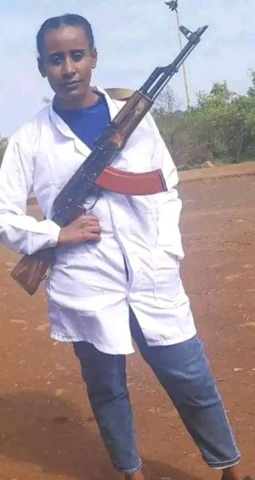

Table 1: Locations of annexation, occupation, ethnic cleansing and mass violence against Amhara and/or Agew people in Ethiopia [table incomplete] (Source: Wikipedia)

Region or Province | Zone, District, or County
Oromia, Hararghe and Western Shewa | Wollega (including East Wollega, West Wollega, Horo Gudru, Kelem); East Hararghe (including Gelemso, Anchar, Daro Lebu, Wefi Dance and other areas); West Hararghe (including Gara Muleta, Asebot Monastery, Gelemso, Bedeno, Weter and other areas); Dire Dawa; Arusi or Arsi (including Shashemene, Arba Gugu and other areas); Bale; Jimma; Ambo and its surroundings
Benishangul-Gumuz | Assosa; Metekel; Kamashi
Annexed-lands in Tigray | Welkait (including Mai-Kadra and other areas)
Amhara: War-related and other situations | North Shewa (including Efratana Gidim, Kewet, Antsokiya Gemzu, and other areas); Gonder (including Gonder city, North and South Gonder); Gojjam (including Bahir Dar city and other areas); Bethe-Amhara Wollo (including North and South Wollo)
Southern SNNPR | Gura Ferda (including Bench–Sheko and other areas)
Others | Gambela; Somali

Of the Burayu and Shashemene massacres, these are selected cases from a series – see crimes by region in Table 1. The Burayu massacre occurred on the outskirts of Addis Ababa in September 2018, Oromo (Qeerroo) youth groups reportedly responsible for the atrocity against non-Oromo residents from the Dorzes, Gamos, and other ethnicities including Amhara (likely one of Ahmed’s first acts after he took power). Reports suggest the perpetrators demonstrated mixed motives (ethnicity and/or religion). In relation to the 2019 Shashemene massacre in Oromia, witness statements suggest an attack by coordinated mobs. The primary targets were Amhara and orthodox Christians from various ethnic groups (Guraghe, Wolayita, Tigre, Oromo). Christian religious leaders were systematically murdered, churches burned to ashes, treasures and literary works destroyed. Such heinous acts appear to have been orchestrated in many regions by a range of perpetrators, the killers demanding conversion to Islam or execution (the assassination of the Oromo singer Hachalu Hundessa here pertinent). For example, Jawar Mohammed, a sometimes acolyte and sometimes competitor of Ahmed who commands a personal militia, is reportedly responsible for mass killings in Oromia. It is demonstrable that there is pre-meditated and often coordinated violence against Amhara and orthodox, the government laying the blame at OLF-OLA, to which Ahmed gives free rein in spite his proclamations otherwise. Abductions, rape and disappearances occur regularly, for example, the abduction of 17 Amhara students from Dembi Dolo University by OLF-OLA in 2019. These girls have not been returned to their families; the case remains open with no obvious action by officials. Other kidnappings have taken place in Wollega (Oromia) and even from the so-named Amhara region (similar to the cross-border abduction of Bedouin girls by Ariel Sharon’s unit 101, where rape was proffered as a prize for the most homicidal soldiers).
As indicated, a series of mass killings and displacements of Amhara, Agew, and other groups have been carried out in the Benishangul-Gumuz & Metekel, and the Southern SNNP regions, as well as multiple attacks launched by OLF-OLA militias into the Amhara region, for example, in northern Shewa province. The attacks involved door-to-door executions in Ataye, Shewarobit, Jewuha, Senbete, Majete, Molale, and the surrounding villages. Ataye was once a vibrant commercial and tourist centre; successive incursions within a short space of time in 2020 ruined much of the city. It was in the process of recovery when an apparently coordinated TPLF-OLF assault in 2021 resulted in further, significant destruction. Majete and the surrounding towns have frequently been bombarded and pillaged by OLF-OLA. Displaced persons and other witnesses declare that the perpetrators were equipped with sophisticated (sniper) arms and artillery, and that state officials were involved in command. The attacks in northern Shewa are part of the pattern of ethnic cleansing for purpose of expansion of Oromo territory. Likewise attacks in and around the capital Addis Ababa have been recurring since 2018, involving targeted killings, forced removal, and destruction of property of non-Oromo residents (for example, in Burayu), causing many to flee before the inward transfer of Oromo settlers. The assaults have been carried out by Oromo (Qeerroo) youth groups, as well as the city police, shooting their pistols and carrying out other acts of abuse at public celebrations and religious festivals, being threatened merely by the plain tri-colour (green-yellow-red) cloth and flag. Systematic administrative changes and aggressive annexation mechanisms are being imposed on the capital to claim it as part of Oromia (much the same as designs for east Jerusalem to be annexed to the apartheid Jewish state).
__________________________

Conclusion
To summarise the annexations and ethnic cleansing of largely Amhara-populated provinces over the two phases of the genocide, see Table 1. The Ahmed regime and the various dictatorial/imperialist regimes (Arab, African, communist, western) that have been involved in the Amhara genocide attempt to de-lionize Ethiopia just as they do with the national flag (see Figure 2a), and in turn to de-lionize the whole of Africa. In doing so, they aim to extinguish a great cultural heritage of humanity.
Figure 2a. Scenes from a protest on Whitehall in London opposite Downing Street on 6 Oct 2022 attended by the current author. Organised by Amhara community UK (www.amhcouk.org). Note the lion on the national flag of Ethiopia, a symbol of a Christian realm that genocidal regimes (whether Arab, African, communist, or western) attempt to delete.

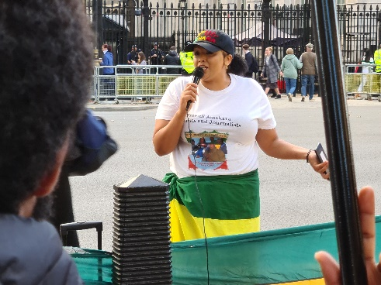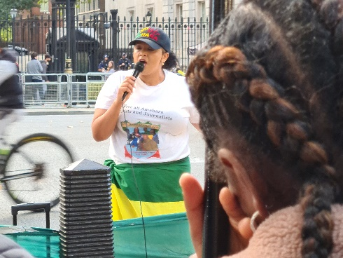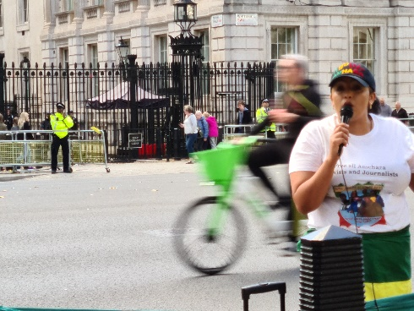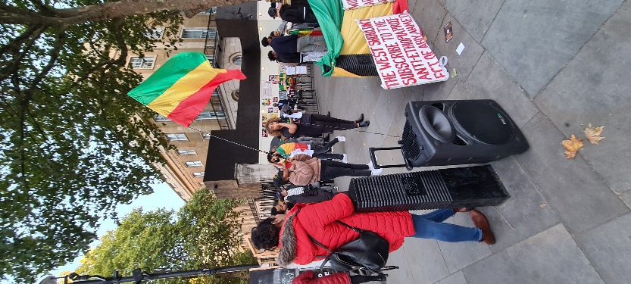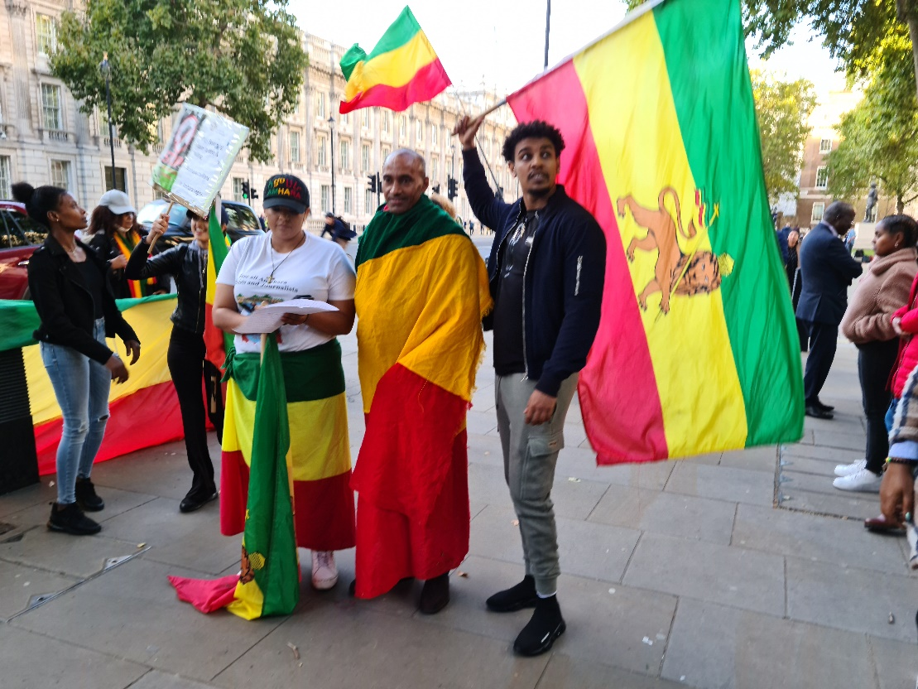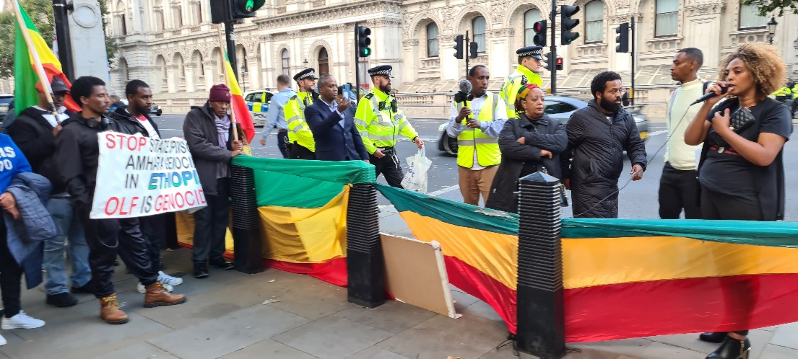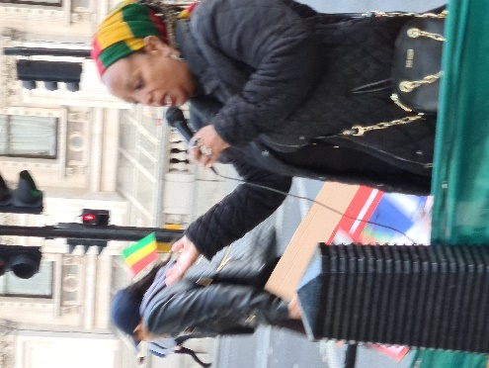

Figure 2b. Scenes from protest on Whitehall in London opposite Downing Street on 6 Oct 2022 attended by the current author. (Source: Mortaza Sahibzada)

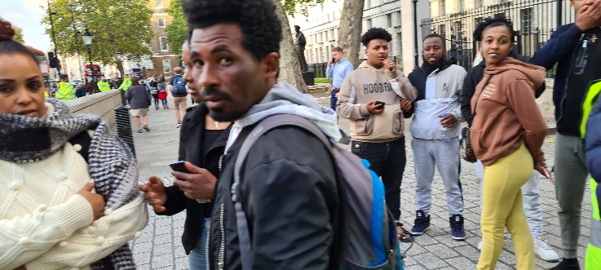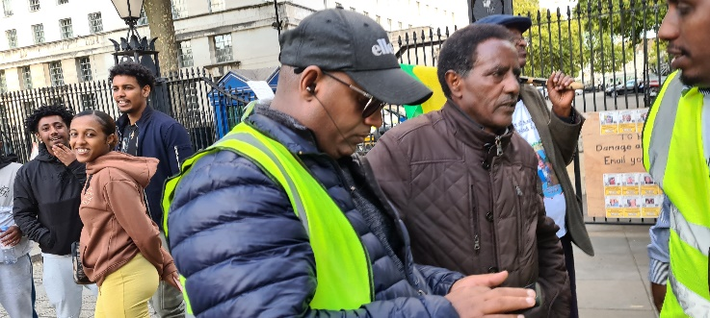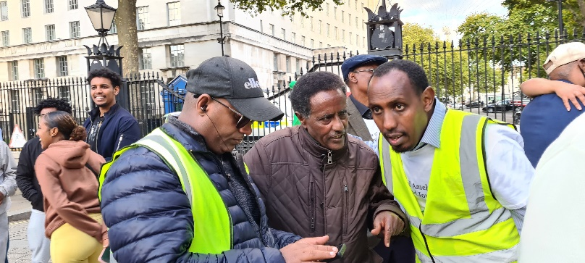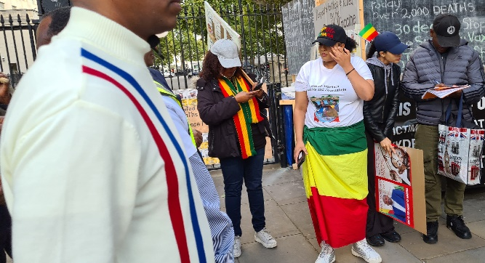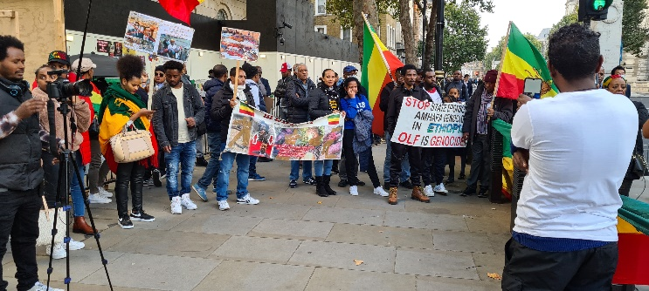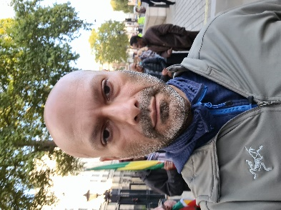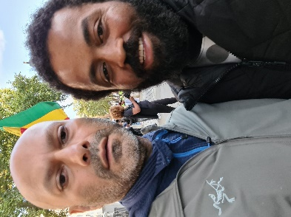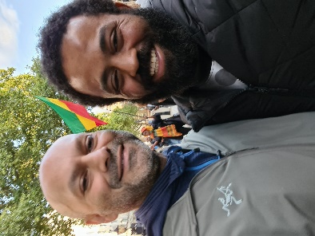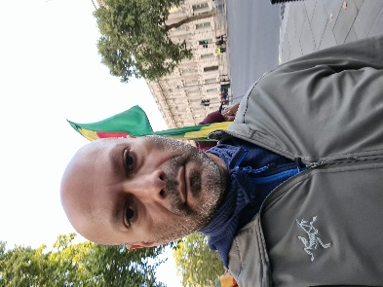

* Based on the dedicated input of Wikipedia contributors, a recurring donation has been made by way of thanks. Discussions with members of the Amhara community UK (www.amhcouk.org) also informed this work.
Whether these actions are carried out by rebels or colonisers, the use of the word ‘vigilante’ to describe violent crimes against civilians, their villages or cultural heritage (such as the Archbishop of Canterbury’s recent description of Jewish extremist attacks on Christian sites in Palestine) is misleading or craven because these incidents clearly fall outside the remit of customary international law relating to war. These incidents target innocent parties and property, rather than known criminals and other elements that promote violence.
The student movement was promoted by the Ethiopian People’s Revolutionary Party (EPRP) and the All-Ethiopia Socialist Movement (MEISON). The EPRP was founded under the name Ethiopian People’s Liberation Organization in April 1972 in west Berlin by exiled students with the assistance of the Popular Democratic Front for the Liberation of Palestine (an offshoot of the Popular Front for the Liberation of Palestine and later renamed the Democratic Front for the Liberation of Palestine). In all ignorance, the latter contributed to events that would fracture Ethiopia within two decades in terms of ethnic demarcations and the separation of Eritrea, involving consequences for the Amhara people not unlike the ethnic cleansing of Palestinians.
The largely Muslim ELF, formed in Cairo in 1961, was likewise supported by Arab/Muslim socialist and nationalist parties across the Middle East and Asia (Egypt in particular has had a historic, hegemonic interest in compromising the integrity of Ethiopia, so it was not an accident that Eritrean separatists coalesced in Cairo). Whereas the ELF laid claim to the mantle of anti-fascism, the Eritrean region being the locus of Italian occupation under Mussolini, it was readily co-opted to its own form of racial determinism. Its secessionist agenda far exceeded the 1950 UN resolution to federate Ethiopia and Eritrea (that, in any case, like the 1947 Partition Plan for Palestine, was imposed on the country without plebiscite).
The bible of the (two) Ethiopian orthodox church(es) is the only one that includes the Book of Enoch (ca. 300 BC) that was an influence on later books (likely on Jesus himself), as is the Book of Enoch accepted only by Jews who are Ethiopian. Ethiopian Jews and Christians share the Ge’ez liturgical language, which is older than Aramaic and Hebrew, one of the oldest Semitic languages, and likely with roots in the even older Afroasiatic languages. The baby Moses was saved by the long stretch of the Blue Nile; Islam exists by virtue of the refuge provided in Abyssinia to Mohammed’s early followers who fled the Quraysh; it is considered a land of Zion by many; it is an extremely complex devotional culture that somehow manages a synthesis of the monotheistic faiths.
The resistance who fought against the Tigray forces in the Amhara region stated that the military directives they received compromised their positions, which favoured the advance of TPLF-TDF forces (questionable commands such as for fighters to retreat south, leaving their weapons and armoured vehicles behind). It may be explained by the infiltration of Oromo and/or Tigray operatives into key federal military posts. Similarly compromised nationalist organizations called in late 2021 for the urgent evacuation of citizens in particular areas, enabling Tigray forces to move without hindrance towards Addis Ababa.
Tigray forces have bombarded the Afar region since mid-2021 for control of strategic Djibouti-Ethiopia connecting lines, but have faced heavy resistance. Repeated attacks have been launched against Afar pastoralists, civilians massacred, rape and pillage commonplace, institutions ransacked, claims of the use of phosphoric munitions. With the TPLF's defeat and withdrawal, booby traps were left in public areas, killing and maiming children.
Of the eighty or so ethnicities in Ethiopia, southern ethnic groups are relatively small in number and lack representation in the political space and military. They have been victim to and remain at risk of silent atrocities and cultural genocide. For example, TPLF forces committed massacres of the Gambela, Anuak, and Ogaden minorities in 2003. There are serious concerns for the Amaro, Korre, and other southerners who face violent coercion under Oromo assimilation mechanisms.

